

The “Art of the Visit”: Supporting Grief and Bereavement in Community Palliative Care

Alisha Leventis, RN, BScN, MN, CHPCN (c)
Grateful appreciation to: Maureen Collins, Nancy Adams, Grant Goddard, and Diane Russett for their shared insights in building these learning modules

Welcome:
At end-of-life, emotional and spiritual distress is not a problem to be solved but an experience that calls for presence, listening, and compassion. Nurses are highly skilled in clinical assessment and intervention, but end-of-life care, death pronouncement, and bereavement visits require relational and reflective competencies that are shaped by experience, education, and organizational support. These moments are pivotal for families and caregivers. Communication that feels rushed, unclear, or overly task-focused may negatively influence the anticipatory grief and bereavement experience. Nurses often form close relationships with clients and families and consequently, are uniquely positioned to support grief within their scope of practice when provided with consistent guidance and resources.
We hope by the end of these learning modules that you will be able to:
- Describe key elements of a standardized grief and bereavement approach that supports families/caregivers while attending to the emotional needs of care providers
- Identify strategies for fostering presence, compassionate communication, and reflective practice during end-of-life, death pronouncement and bereavement visits

Table of Contents:
Module One: Anticipatory Grief Slide Notes 4
Module Two: Supporting a Pronouncement Slide Notes 11
Module Three: Supporting Bereavement Slide Notes 15
Module Four: Supporting Self Care Slide Notes 20
Communication Support Frameworks 27
Pocket Cards 31
Self-Compassion Guidebook: An Experiential Approach 33
(Champlain Hospice Palliative Care Program)

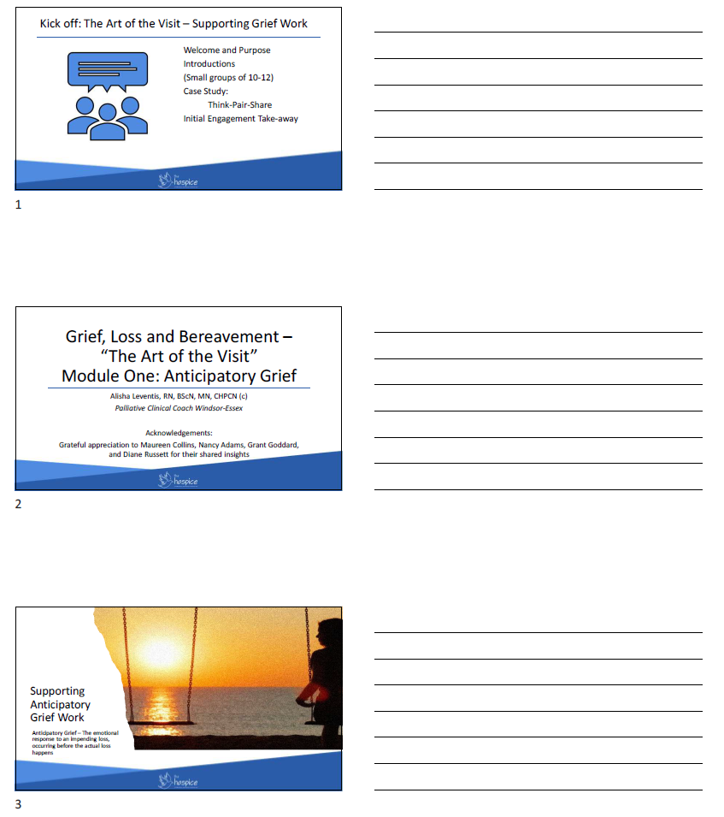
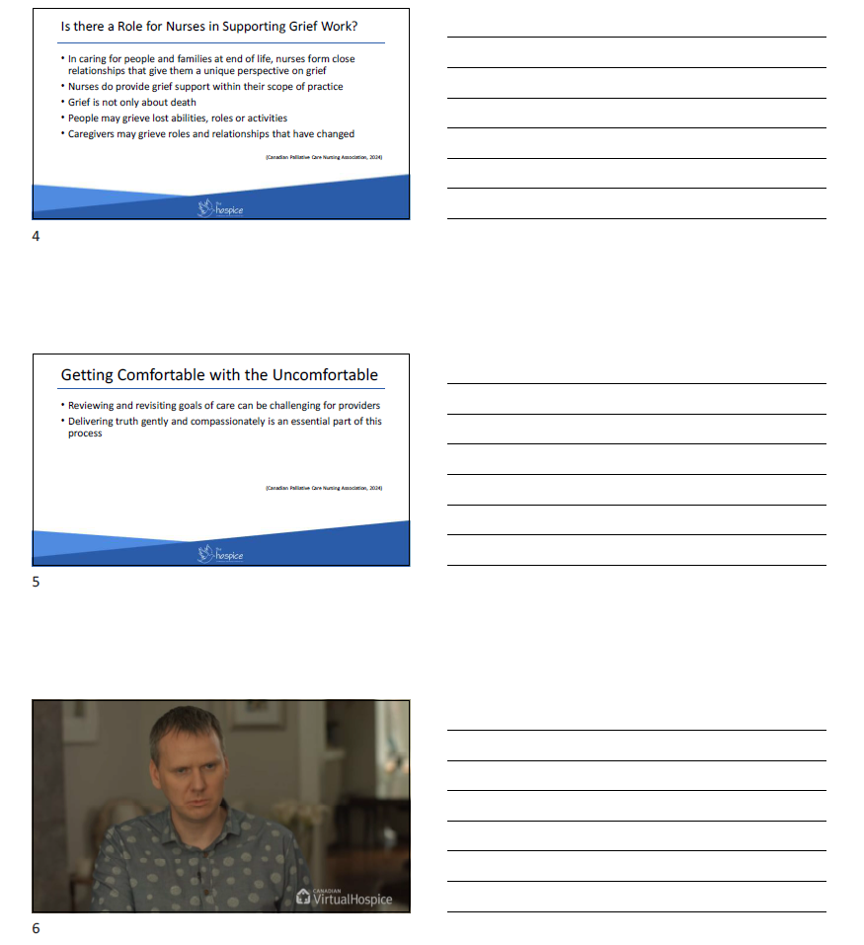
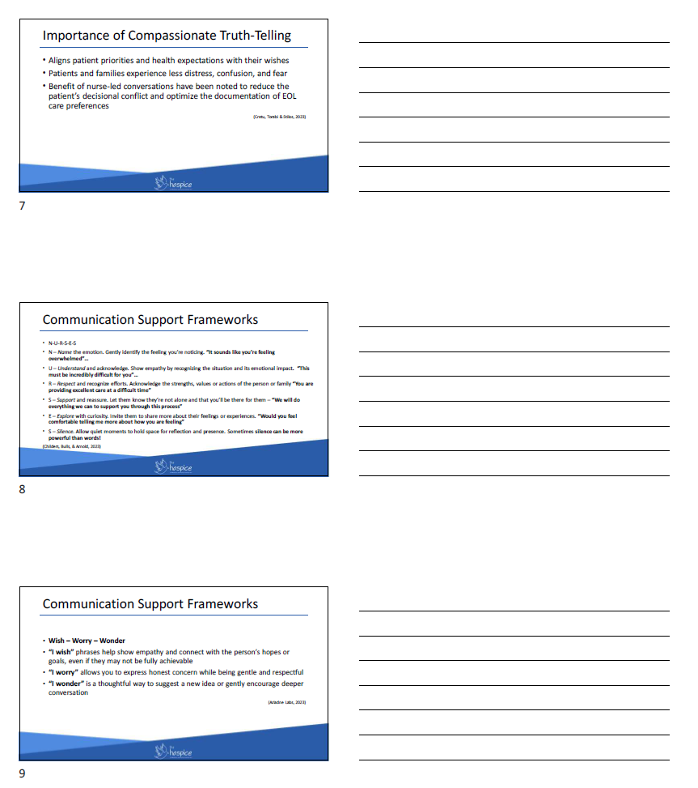
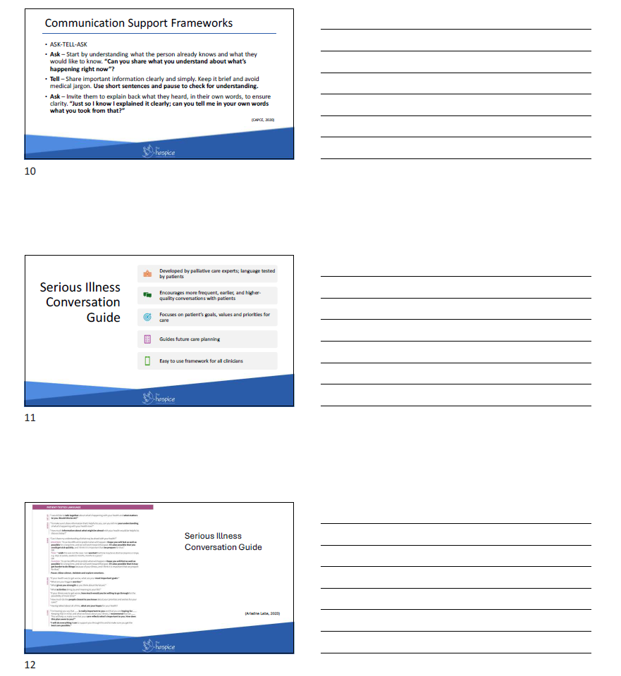
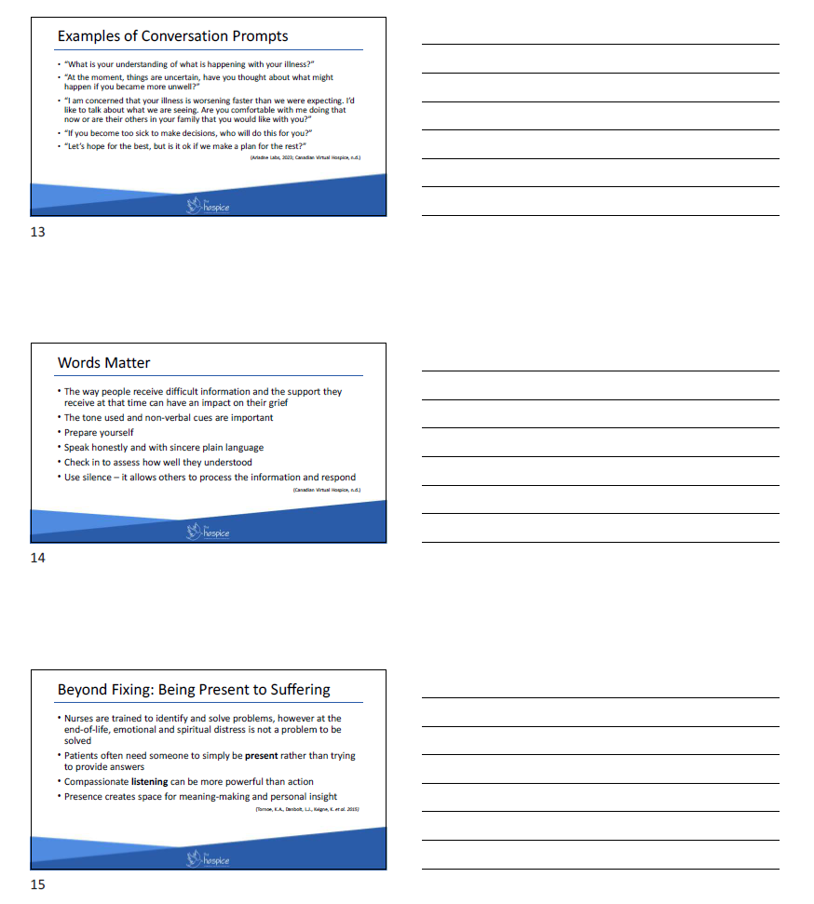
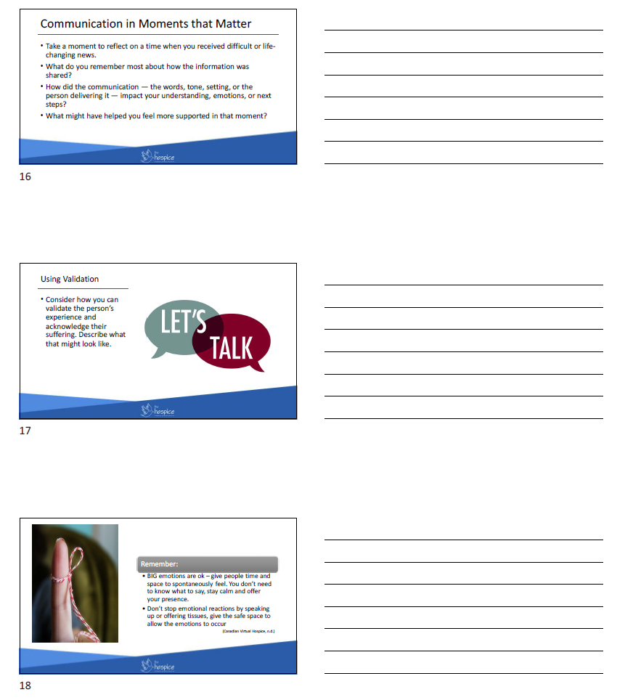
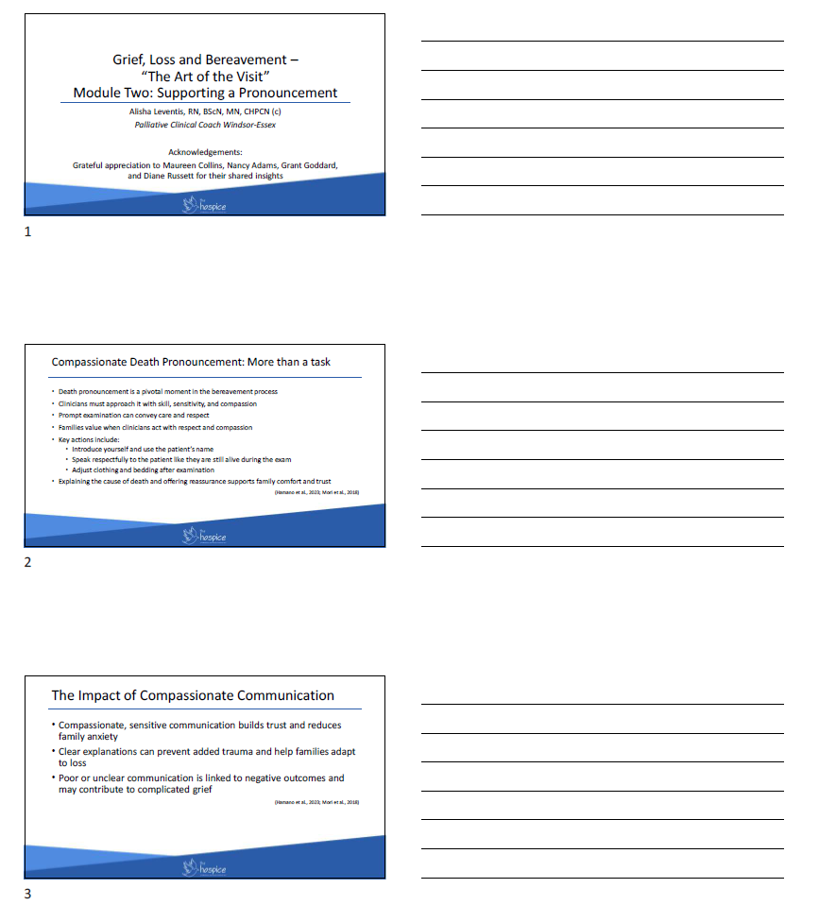
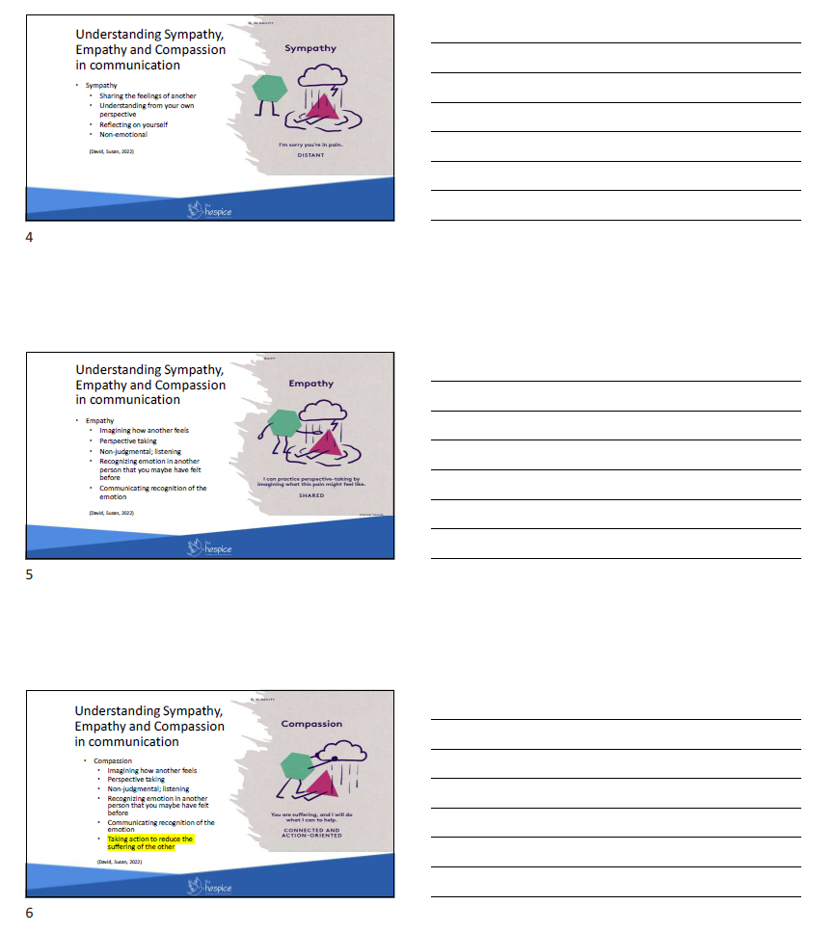
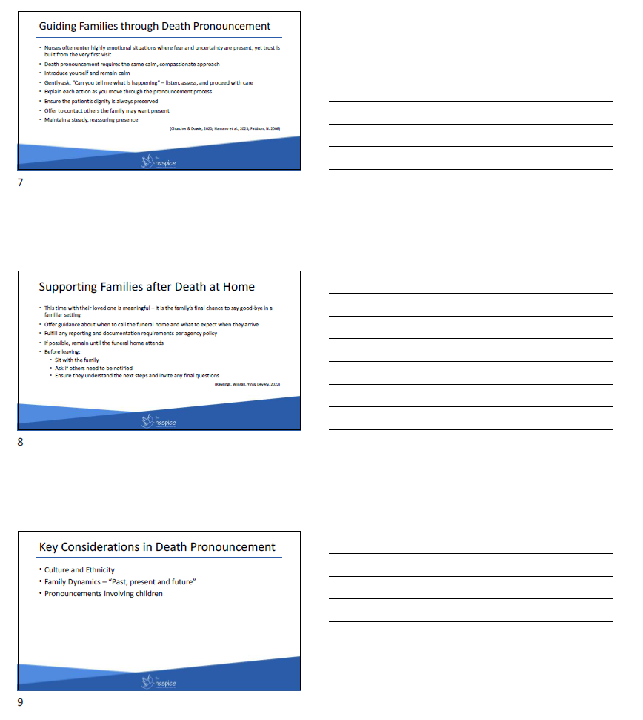



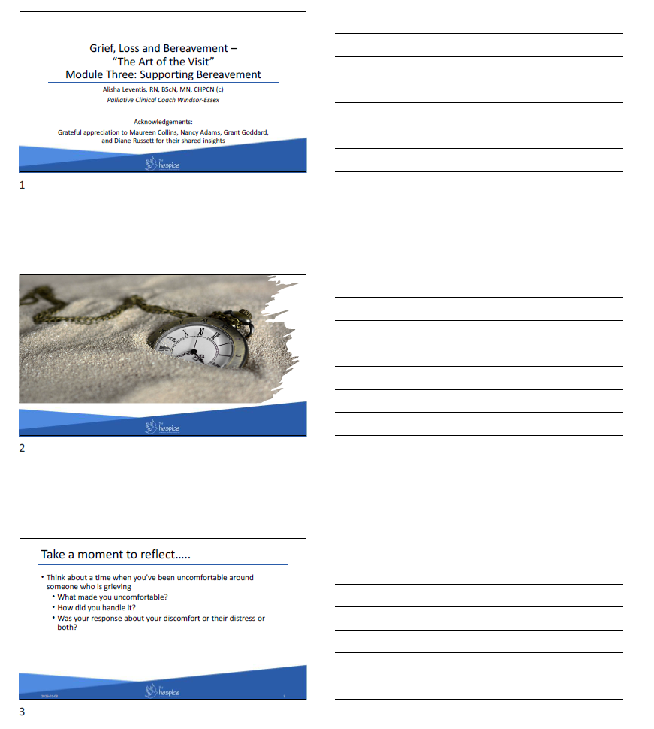
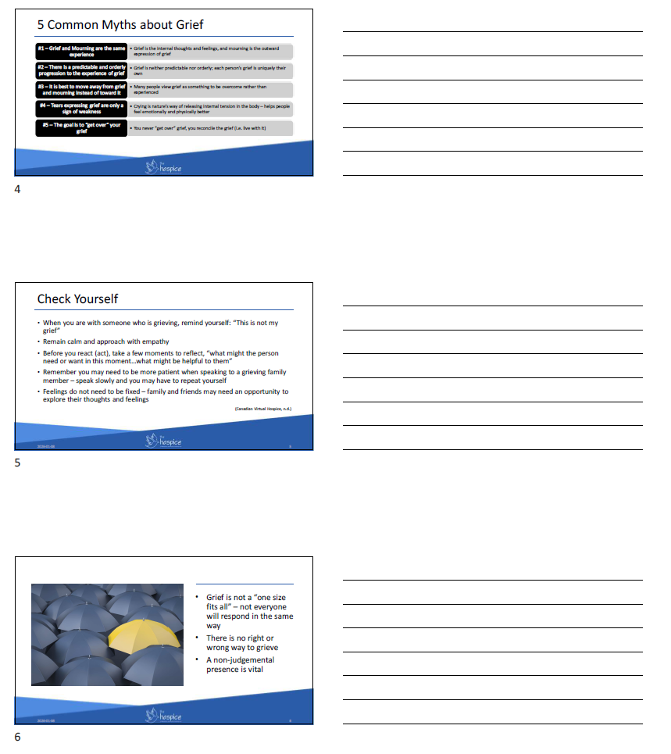
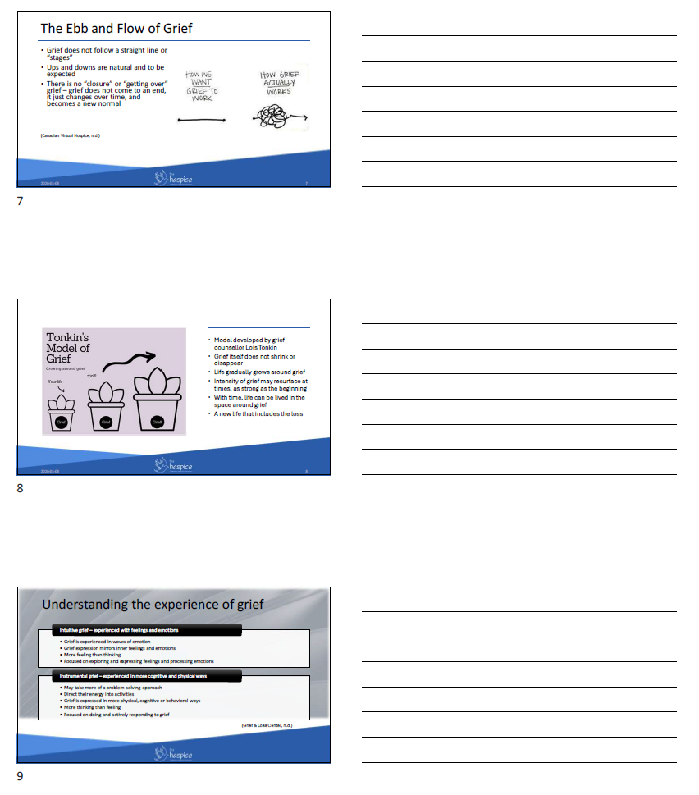
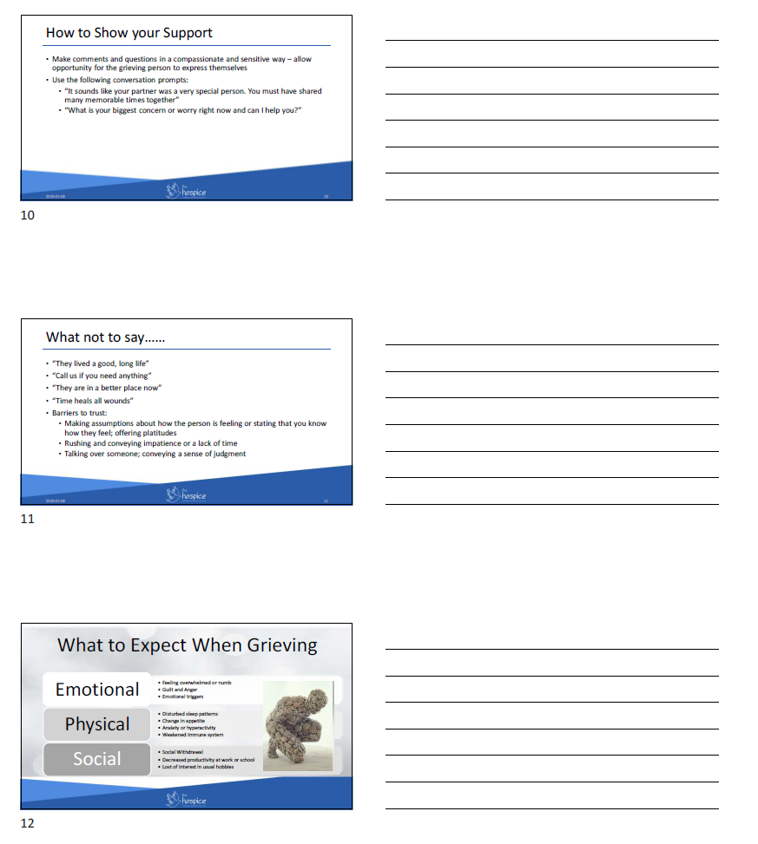

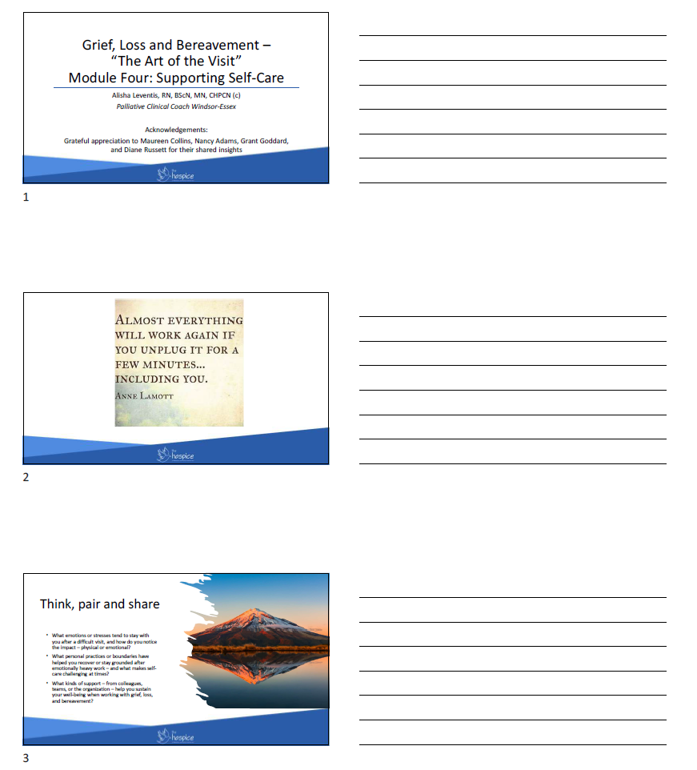
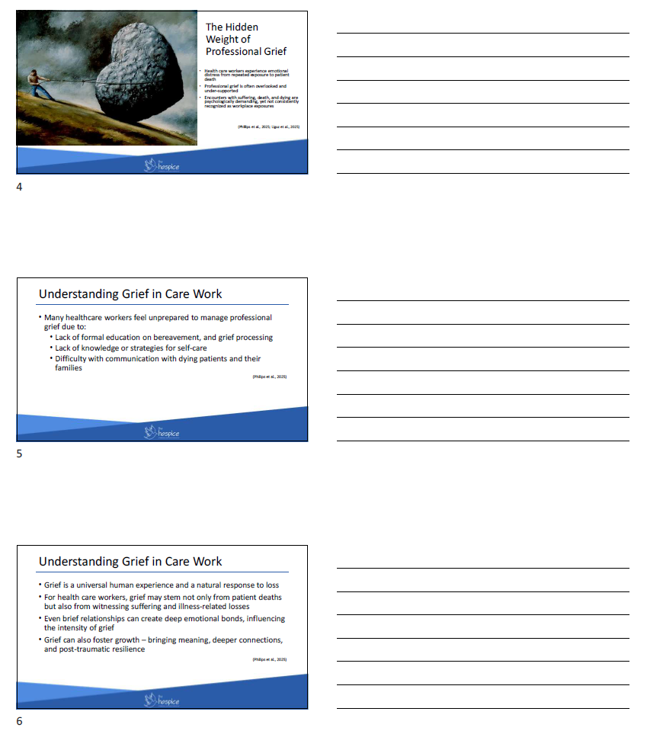
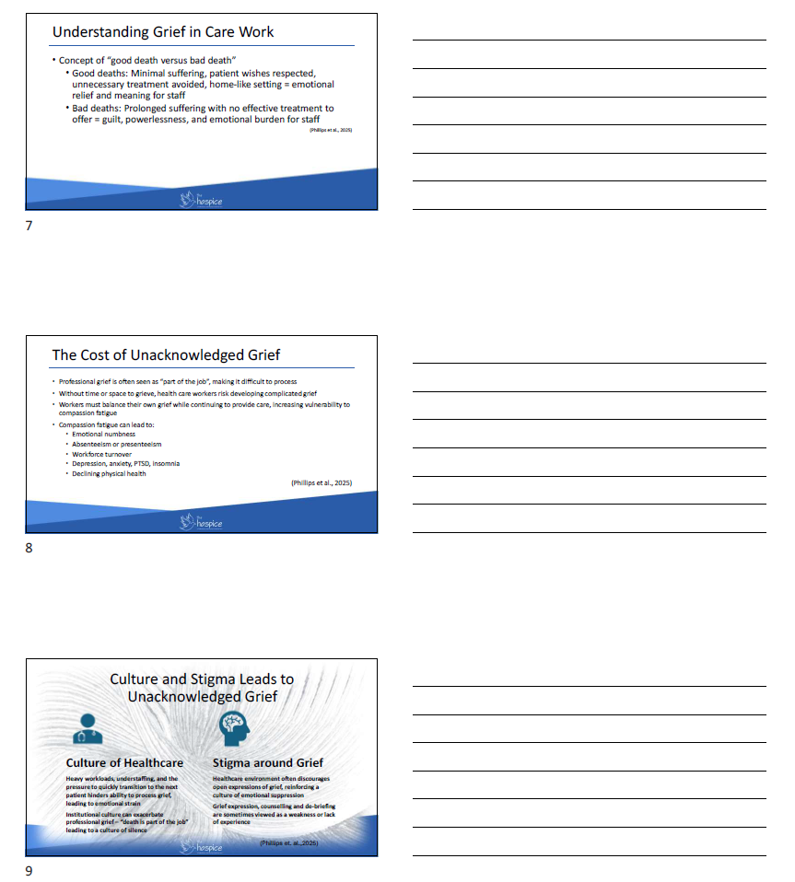
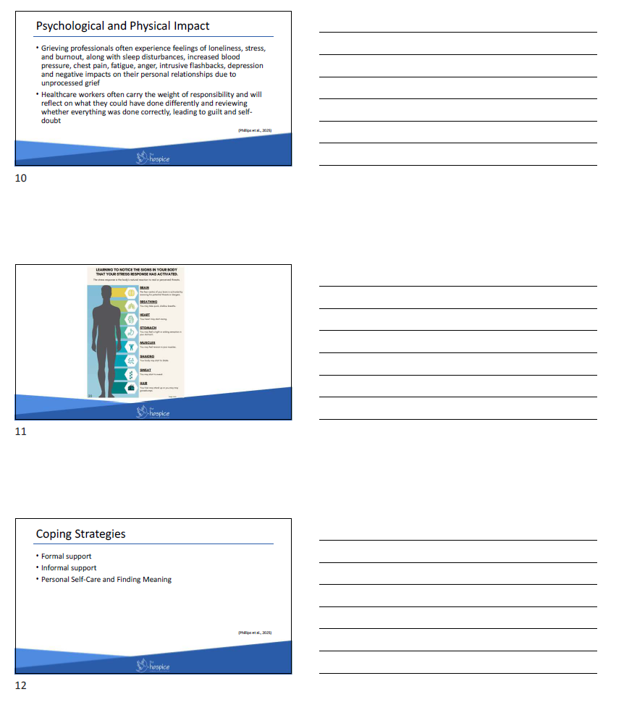
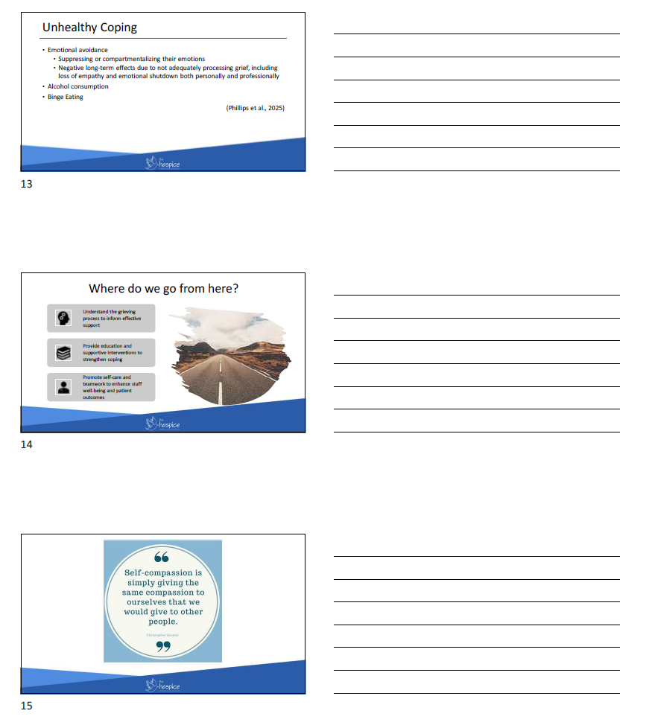
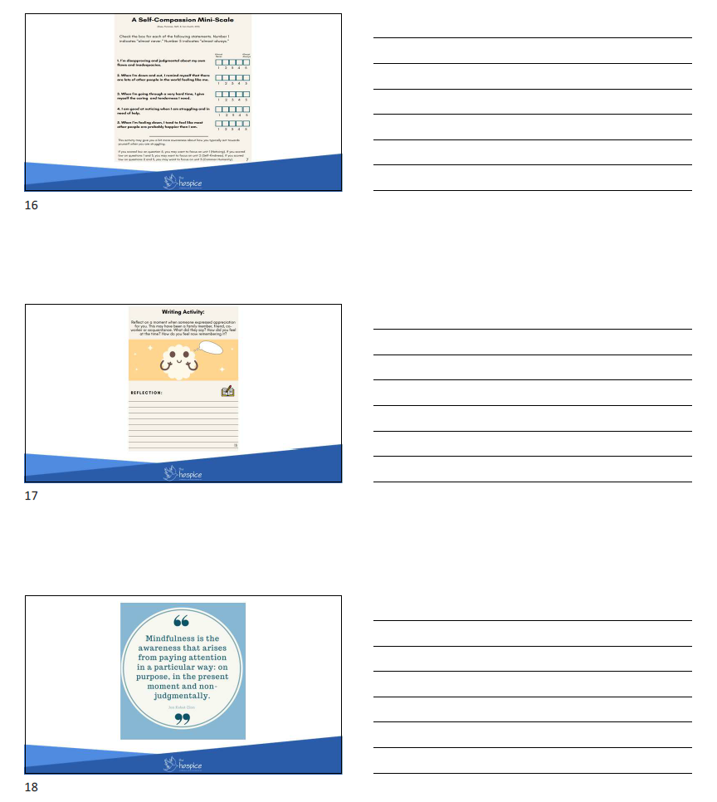
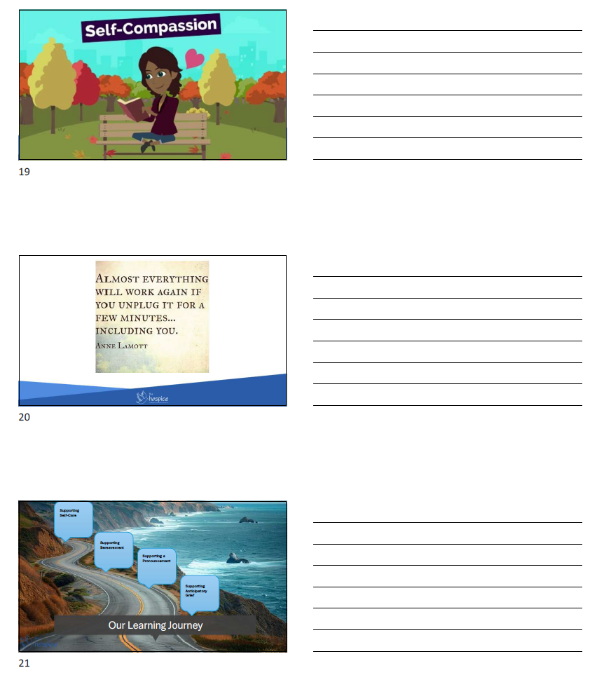
Communication Support Frameworks
N-U-R-S-E-S
- N – Name the emotion. Gently identify the feeling you’re noticing. “It sounds like you’re feeling overwhelmed…”
- U – Understand and acknowledge. Show empathy by recognizing the situation and its emotional impact. “This must be incredibly difficult for you…”
- R – Respect and recognize efforts. Acknowledge the strengths, values or actions of the person or family. “You are providing excellent care at a difficult time”
- S – Support and reassure. Let them know they’re not alone and that you’ll be there for them. “We will do everything we can to support you through this process”.
- E – Explore with curiosity. Invite them to share more about their feelings or experiences. “Would you feel comfortable telling me more about how you are feeling?”
- S – Silence. Allow quiet moments to hold space for reflection and presence. Sometimes silence can be more powerful than words!
(Childers, Bulls, & Arnold, 2023)

Communication Support Frameworks
WISH. WORRY. WONDER
- “I wish” phrases help show empathy and connect with the person’s hopes or goals, even if they may not be fully achievable.
- “I worry” allows you to express honest concern while being gentle and respectful.
- “I wonder” is a thoughtful way to suggest a new idea or gently encourage deeper conversation. (Ariadne Labs, 2023)

ASK – TELL – ASK
- Ask – Start by understanding what the person already knows and what they would like to know. “Can you share what you understand about what’s happening right now?”
- Tell – Share important information clearly and simply. Keep it brief and avoid medical jargon. Use short sentences and pause to check for understanding.
- Ask – Invite them to explain back what they heard, in their own words, to ensure clarity. “Just so I know I explained it clearly; can you tell me in your own words what you took from that?”
(CAPCE, 2020)
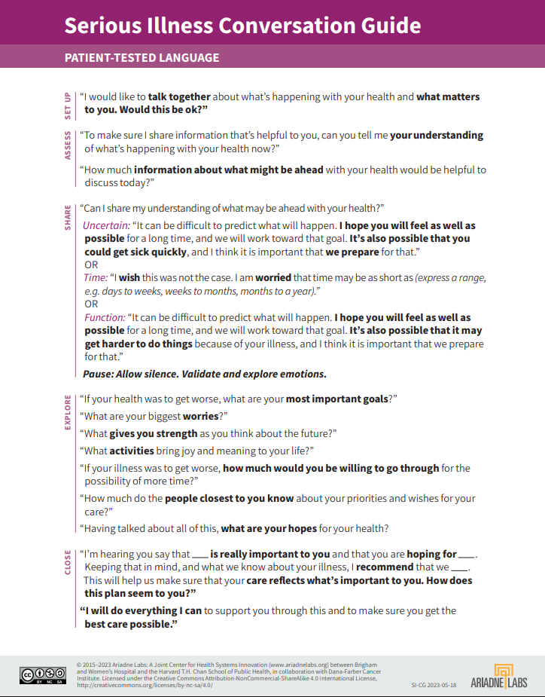


N-U-R-S-E-S
N-Name the emotion
“It sounds like you’re feeling…”
U-Understand & Acknowledge
“This must be difficult”.
R-Respect & Recognize
Acknowledge strengths
S-Support & Reassure
“We’re here with you.”
E-Explore with curiosity
“Tell me more…”
S-Silence
Pause & be present

Triple W
Wish
Align with hopes
“I wish…”
Worry
Express concern gently
“I worry…”
Wonder
Invite reflection
“I wonder…”

Use tone that is calm, curious, and respectful
Ask. Tell. Ask
Ask
What do they know?
What do they want to know?

Tell
Simple, brief, no jargon, pause

Ask
Teach-back
“Can you tell me…”

Quick Reference:
Pocket Cards with Communication Tips – Badge Sized


We gratefully acknowledge Champlain Hospice for permission to use and adapt their Self-Compassion Guidebook in this training.
